Jason Pham

Applied Programming Concepts

Andrew Lin & Mohamed Nezad

6/20/21

Process model and Version Control

**Waterfall Model**

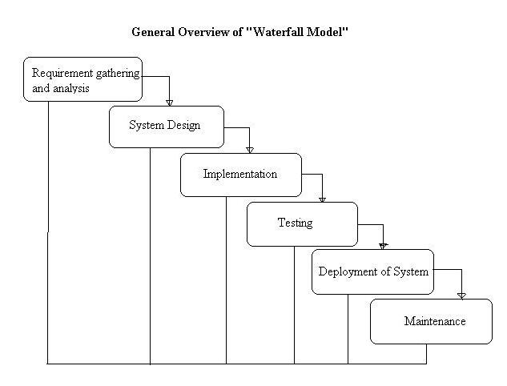

* This process model has multiple phrases, the result of each phase should be documented and approved.
  + By the nature of method, each phase should only start when the previous phase has finished.

**Phase 1**: Requirements definition

In this phase, we will determine the services, constraints, and goal of the scheduling system. The duration of this phase can be around an hour to possibly a day.

* Services: scheduling system for instructors, students, and admin, each type of user will be allowed to access to certain services.
  + student – can register, can see available courses and their own schedule.
  + instructor – can see available courses and their own course roster.
  + admin – can see everything, can edit courses/users/schedules.
* Constraints: should give access for 100 students, 10 instructors, and 1 admin, however, we will test with fewer.
* Goals: creating a scheduling system that is similar to Leopard Web with useful functionalities.

**Phase 2:** Design and system software

We will be establishing the overall system architecture and define the fundamental software abstractions and relationships; this phase can last about a day or couple day. This system will include a database of users and courses with course information. The base class will be user class with attributes of first name, last name, and ID. Then we will have derived class of students, instructors and admin, each derived class will have functions to accommodate the needs of the defined user.

**Phase 3:** Implementation and unit testing

This is the phase where code will be written and the components will be tested, which can weeks or months (for this system approximately 1-2 months). The functionality of component should be thoroughly tested to ensure that the program is working as intended in previous phases. The components to be tested are database, functions control of each type of user, and possibly the number of access allowed for each type of user.

**Phase 4:** Integration and system testing

This when all individual components are integrated in a system and overall system is tested, the process can take days or weeks to be finished. We should test scheduling, course information viewing, entering user as student, instructor, and admin along with control that implemented for each type of user, checking if the information is printed out accurately.

**Phase 5:** Operations and maintenance

This is the only phase of the process model where the duration can be undefined due the unpredictable issue may occur when the program is used over time. This phase is there to ensure bug fixes, and updates when applicable. The installation for this program can take few minutes to hour in some case.

**Incremental model**

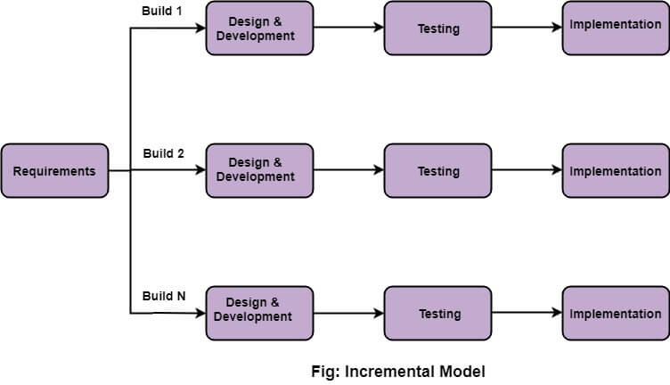

**Initial version:**

* The system will be included database along with course information.
* Student will be able to search courses, add/drop courses, print their schedule.
* Instructor will be able to print their schedule, print their class list, and search for courses.
* Admin will be able to add courses to the system, remove courses from the system, add/remove users, add/remove student from a course, search and print rosters and courses.

**Intermediate versions:**

* These versions will be adding onto the initial version other features and functionalities.
* Controlled printing function as admin, instructor or student will be implemented.

**Final version:**

* This version is combined from the initial version with however many intermediate versions that are created.

**Integration and Configuration Model**

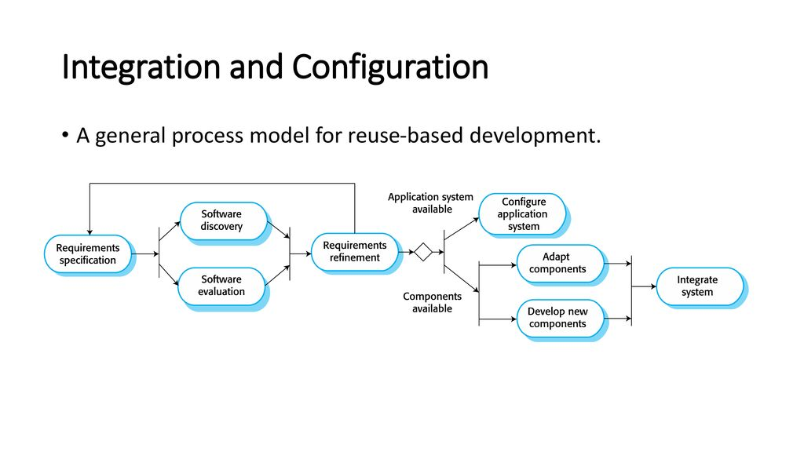

For this model, it is reuse-oriented which means we can use existing software that can be found online to integrate a program that is similar to Leopardweb scheduling system. There are stages for this model, component analysis which you will find and study existing software that satisfies some or all requirements specification; Requirement modifications, you then revise original specs to your own system; System design, use found the components, and modify/add as needed; final stage is development and integration and system validation.

**PHP**:  a general-purpose scripting language especially suited to web development. When I learned about web developing, I was introduced to PHP, using existing code that already existed, I was able to modify and alter it into a more simpler scheduling system existing as a web interface.

Sources

PHP. https://code-projects.org/simple-scheduling-system-in-php-with-source-code/